**SSH connection between Two servers**

Server 1 kpk and security group test1



Server 2 Praveen security group test2

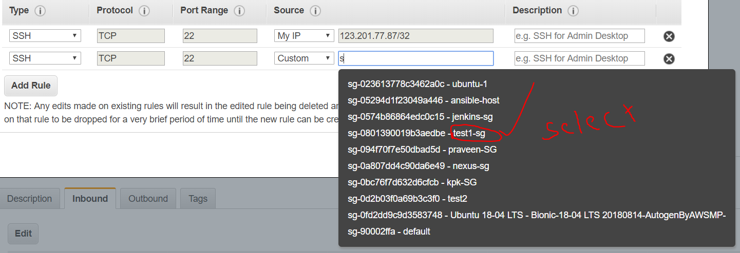

Login into server 2(praveen)

Adduser “name”

Follow screenshot

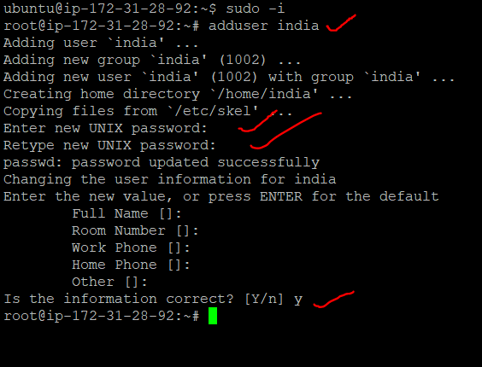

Add user in visudor file

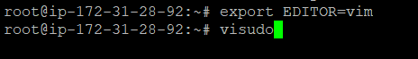

Change passwordauthentication in sshd config file



Sshd service restart



**Login into server 1(kpk)**

**Ssh** keygen steps

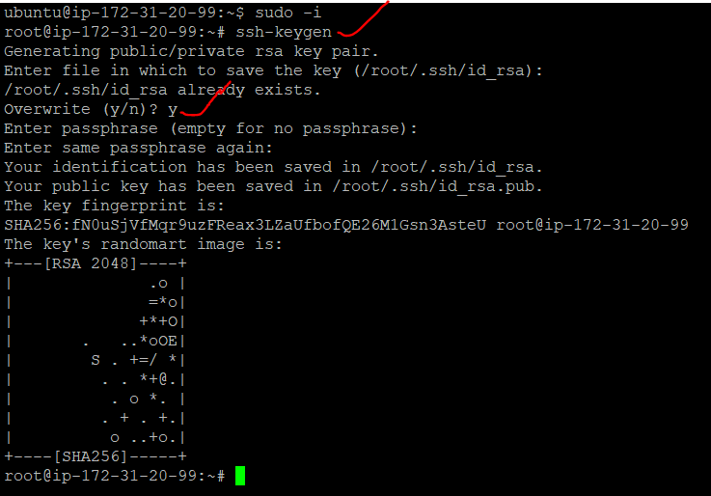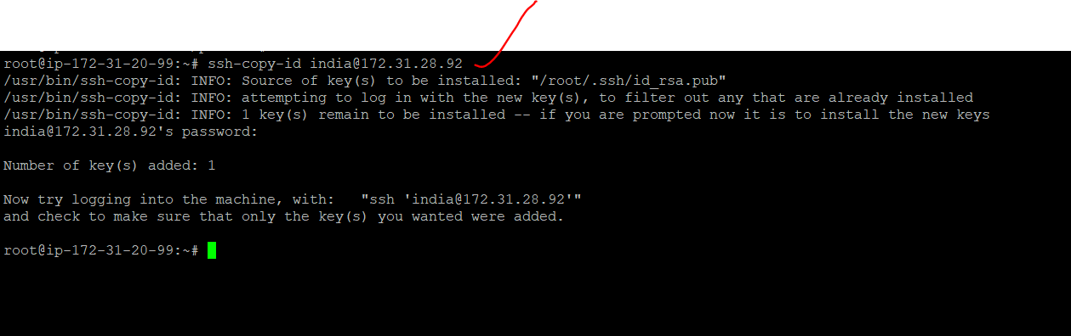

Creat directory and file then copy from server 1 to server 2

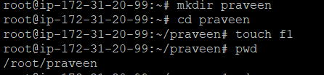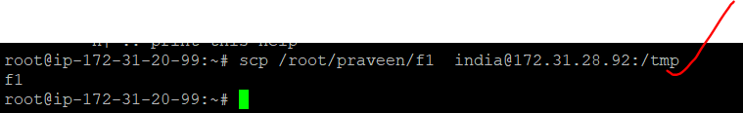

Then try ping